Neil Barot

Jacob Pinksa

Jared Pinksa

Anthony Ngo

Jalal Omer, Ph.D.

11 September 2022

**Database Project**

**System Description**

The database system aims to help track the conditions of various 3D printers and filaments inside of a makerspace in order to provide valuable insights. The system tracks what times the machines are scheduled, the traffic at each machine, the model of the printer, the filament type and quantity in each printer, as well as various other useful information. This information can be used by the owner of the maker space in order to check the availability of their 3D printers and what project they are currently being used for. The system also has a lot of value when it comes to ordering new filament as the owner will be able to use the data in order to buy the appropriate amount and type of filament depending on the usage.

**Context Diagram**

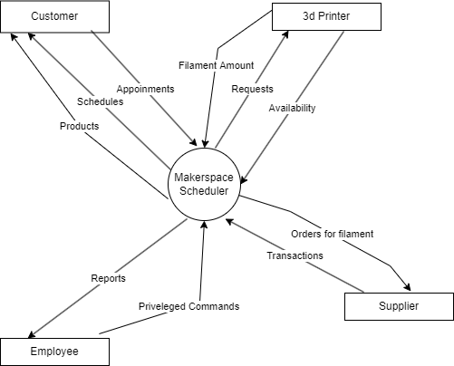

**Functional Requirements**

F1: The application can schedule a maker space.

F2: The application can report which machines need a refill on the filament.

F3: The application can give an average of how many deliveries the company makes in a week.

F4: The application can report when a specific machine is available next.

F5: The application can report on how busy every machine is.

F6: The application can find the best cost across multiple sources to refill a machine.

**Non-functional Requirements**

NF1: The response time of the application to tell the user what machines are currently available for use.

NF2: The scalability of the application so that it can perform as expected when multiple users are accessing it simultaneously.

NF3: The security of the application to prevent unauthorized access. For example, the user being unauthorized to find the average deliveries that the company makes in a week.

NF4: The usability of the application so that the user can easily navigate through it and perform the tasks that they need to do.

NF5: The maintainability of the application so that it remains functional for a long period of time and can keep up with rapidly changing requirements.

NF6: The availability of the application to the users when the system needs to be restored after a failure.